1.

Customer(customerNo, name, email)

Orders(orderNo, orderDate, handingCost, customerNo)

Includes(unitPrice, quantity, orderNo, productNo)

Products(productNo, productName, listPrice)

2.

SQL> create table Customer(

2 customerNo int not null primary key,

3 name varchar(255),

4 email varchar(255));

Table created.

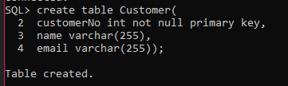

SQL> create table Orders(

2 orderNo int not null primary key,

3 orderDate date,

4 handingCost number(10,2),

5 customerNo int not null,

6 foreign key(customerNo) REFERENCES Customer(customerNo)

7 );

Table created.

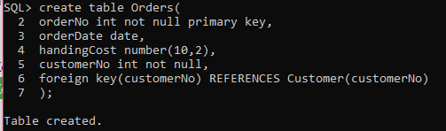

SQL> create table Product(

2 productNo int not null primary key,

3 productName varchar(255),

4 listPrice number(10, 2));

Table created.

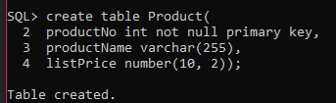

SQL> create table Includes(

2 unitPrice number(10,2),

3 unitQuantity number(10,2),

4 orderNo int not null,

5 productNo int not null,

6 foreign key(orderNo) references orders(orderNo),

7 foreign key(productNo) references Product(productNo)

8 );

Table created.

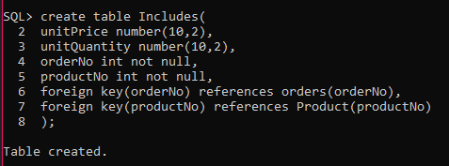

3.

SQL> insert all

2 into Customer(customerNo, name, email) values(1, 'Hridoy', 'Hridoy@mail.com')

3 into Customer(customerNo, name, email) values(2, 'Hasan', 'Hasan@mail.com')

4 into Customer(customerNo, name, email) values(3, 'Monisha', 'Monisha@mail.com')

5 into Customer(customerNo, name, email) values(4, 'Ahamed', 'Ahamed@mail.com')

6 into Customer(customerNo, name, email) values(5, 'Sajeeb', 'Sajeeb@mail.com')

7 select * from dual;

5 rows created.

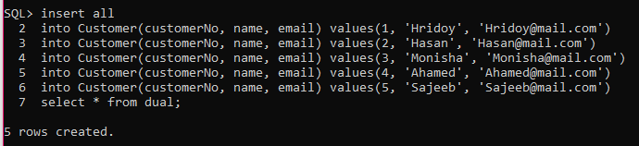

SQL> insert all

2 into Product(productNo, productName, listPrice)values(1, 'pen', 10)

3 into Product(productNo, productName, listPrice)values(2, 'pencil', 9)

4 into Product(productNo, productName, listPrice)values(3, 'paper', 2)

5 into Product(productNo, productName, listPrice)values(4, 'ball', 10)

6 into Product(productNo, productName, listPrice)values(5, 'marker', 25)

7 select * from dual;

5 rows created.

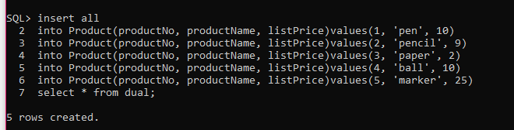

SQL> insert all

2 into Orders(orderNo, orderDate, handingCost, customerNo) values(1, TO_DATE('2018/12/16 01:00:00', 'yyyy/mm/dd hh:mi:ss'), 100, 1)

3 into Orders(orderNo, orderDate, handingCost, customerNo) values(2, TO_DATE('2018/12/15 02:00:00', 'yyyy/mm/dd hh:mi:ss'), 120, 2)

4 into Orders(orderNo, orderDate, handingCost, customerNo) values(3, TO_DATE('2018/12/17 03:00:00', 'yyyy/mm/dd hh:mi:ss'), 130, 3)

5 into Orders(orderNo, orderDate, handingCost, customerNo) values(4, TO_DATE('2018/12/11 04:00:00', 'yyyy/mm/dd hh:mi:ss'), 400, 4)

6 into Orders(orderNo, orderDate, handingCost, customerNo) values(5, TO_DATE('2018/12/14 05:00:00', 'yyyy/mm/dd hh:mi:ss'), 800, 5)

7 select * from dual;

5 rows created.

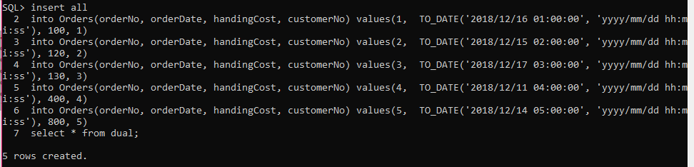

SQL> insert all

2 into Includes(unitPrice, unitQuantity, orderNo, productNo)values(100, 200, 1, 1)

3 into Includes(unitPrice, unitQuantity, orderNo, productNo)values(9, 300, 2, 2)

4 into Includes(unitPrice, unitQuantity, orderNo, productNo)values(2, 400, 3, 3)

5 into Includes(unitPrice, unitQuantity, orderNo, productNo)values(10, 100, 4, 4)

6 into Includes(unitPrice, unitQuantity, orderNo, productNo)values(25, 50, 5, 5)

7 select * from dual;

5 rows created.

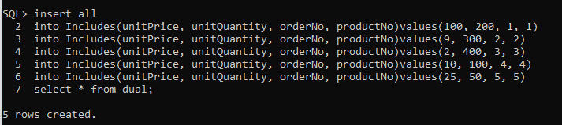

4.

SQL> select Product.productName, Includes.unitQuantity

2 from((Includes

3 INNER JOIN Product ON Includes.productNo = Product.productNo)

4 INNER JOIN Orders ON Includes.orderNo = Orders.orderNo AND orderDate >= TO_DATE('2018/01/01', 'yyyy/mm/dd')

5 AND orderDate <= TO_DATE('2018/12/31','yyyy/mm/dd'));



5.

SQL> select Customer.name from Customer

2 INNER JOIN Orders ON

3 Orders.customerNo = Customer.customerNo

4 order by orderDate asc;

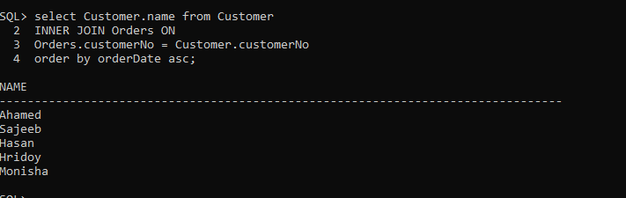

6.

There are three joins.

For question 4 and 5 , I have used inner join.

7.

My experience with sql query still now is,

Create table, insert value, delete value, update value, join, select, where etc.